Biology Accelerated Name: __________________________________________

Date: _______________

Period: ____

**Mechanisms of Evolution**

**Evolution** is a change in the gene pool of a population that is observed over many generations. This process is represented in the image below.

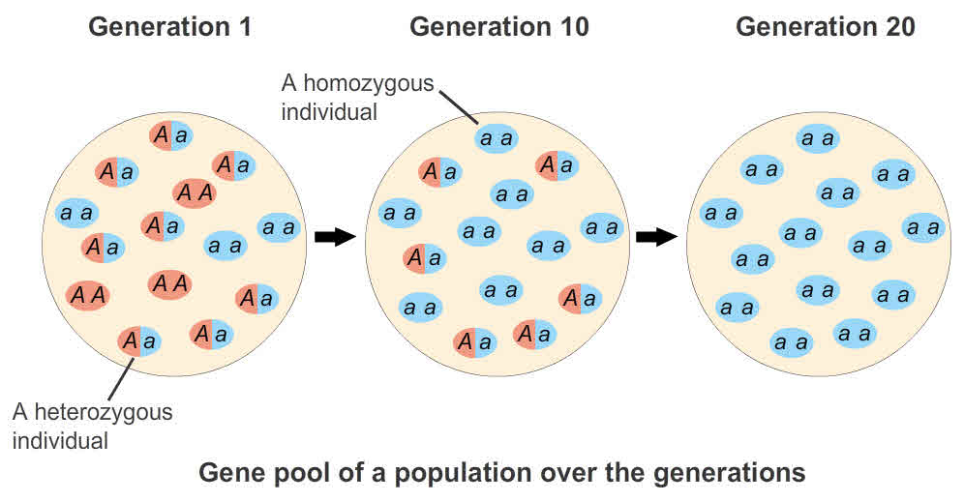

These genetic changes can occur due to several *mechanisms of evolution.* Two mechanisms that we will focus on in this activity are genetic drift and natural selection.

* **Genetic drift** is a process by which the genetic traits in a population change due to random chance survival and reproduction of particular individuals
  + For example, a hurricane could randomly kill many seagulls that happen to have brown feathers. Future generations of seagulls have a higher percentage of white-feathered individuals.
* **Natural selection** is a process by which individuals with certain genetic traits are more likely to survive and pass on those traits to their offspring.
  + For example, in a certain forest small seeds embedded deep in the plant are more common than large seeds. Because of this, birds with long, skinny beaks can collect more food than birds with wide beaks. With the greater amount of food comes greater energy production and resources to dedicate to reproduction. Future generations of birds have higher percentages of individuals with long skinny beaks.

**Answer all of these questions on a Google Document in your Google Drive folder. All completed data tables should be included in this Google Doc as well!**

*Pre-lab questions:*

1. What is the major difference between genetic drift and natural selection?
2. In the example of natural selection given above, predict what would happen to the population of birds if no individuals had the gene for a long, skinny beak.
3. Write an additional example of genetic drift.
4. Write an additional example of natural selection.

*Model:* A pond is home to populations of fish and algae. The algae, which the fish eat to gain energy, is not evenly distributed in the pond. It is clumped in various areas around the pond.

*Experiment A:* Uniform Population of Fish in a Pond

1. Open up the model (<https://www.slnova.org/djwendel/projects/261339/edit/>
2. Click “Run Code”
3. Set the Algae Clumpiness to 8
4. Click “Create Yellow Fish”
5. Click “Run for 30”
6. Record the number of yellow fish remaining as well as the number of algae in the table below
7. Repeat 2 more times

|  |  |  |
| --- | --- | --- |
| **Trial #** | **# Yellow Fish at 30 seconds** | **# Algae at 30 seconds** |
| **Trial 1** |  |  |
| **Trial 2** |  |  |
| **Trial 3** |  |  |

*Experiment A Analysis Questions:*

1. Were your results for each trial the same? If not, why do you think this might be? {HINT: click on “Create Yellow Fish” a few times and look at how the yellow fish are distributed in the bond each time you start a new trial}
2. What do you think the word “uniform” indicates in the title of this experiment?
3. Did the population of yellow fish evolve? Why or why not? Use data to support your answer.

*Experiment B:* Multi-Color Fish with Uniform Traits

In this simulation, the population is composed of fish of several different colors. As before, all the fish, regardless of their color, have the same traits. In this case, color is only a cosmetic difference and has no effect on the survival or reproduction of the fish.

1. Make sure the “Algae Clumpiness” is set to 8
2. Click “Create Multi-Color Fish.”
3. Record the starting number of each color of fish in the “Initial Number of Fish” column in the table below
4. Click “Run for 60” and observe the simulation as it runs
5. When the simulation stops, look at the fish counters again and record the numbers of each color of surviving fish in the “Trial 1” column.
6. Repeat the procedure 2 more times.

|  |  |  |  |  |
| --- | --- | --- | --- | --- |
| **Fish Color** | **Initial # of Fish** | **Trial 1 Survivors** | **Trial 2 Survivors** | **Trial 3 Survivors** |
| **Red** |  |  |  |  |
| **Yellow** |  |  |  |  |
| **Turquoise** |  |  |  |  |
| **Magenta** |  |  |  |  |

*Experiment B Analysis Questions:*

1. Which color fish survived and was most plentiful for each of your trials?
2. A group of students ran the simulation twice. In their first run, the yellow fish became the most plentiful. In the second run, red became the most plentiful. Why does one color become more plentiful than the others if all the fish have exactly the same traits and behaviors?
3. Did the population of multi-colored fish evolve? If so, by what mechanism? Use data to support your answer.

*Experiment C* Multi-Color fish with Variable Traits

In this experiment, the color of the fish will represent a specific genetically determined trait: reproductive strategy. The trait is modeled by the amount of energy (algae) a fish must accumulate before it can reproduce. The different colored fish also pass along different amounts of energy to their offspring. The table below summarizes the energy differences.

|  |  |  |  |
| --- | --- | --- | --- |
| Reproductive Strategy | Color | Energy Units Needed to Reproduce | Energy Units Passed on to Offspring |
| Very Fast | Red | 20 | 8 |
| Moderate | Yellow | 40 | 16 |
| Slow | Turquoise | 70 | 28 |
| Very Slow | Magenta | 100 | 40 |

*Before you run this experiment, make a prediction about the following:*

1. Which color offspring will die more quickly without food nearby?
2. Which color offspring will survive the longest without food nearby?
3. Which color fish will persist the longest in the population?

*Procedure:*

1. Make sure the “Algae Clumpiness” is still set to 8
2. Click “Create Multi-Trait Fish”
3. Record the initial number of each color fish in the “Time 0” Row of the table below.
4. Click “Run for 90” and observe how the number of fish has changed
5. Enter data of surviving fish in the “Time 90” row of the table
6. Repeat this procedure 2 more times

|  |  |  |  |  |
| --- | --- | --- | --- | --- |
| Run 1 | Surviving Fish Colors | | | |
| Time | Red | Yellow | Turquoise | Magenta |
| 0 |  |  |  |  |
| 90 |  |  |  |  |

|  |  |  |  |  |
| --- | --- | --- | --- | --- |
| Run 2 | Surviving Fish Colors | | | |
| Time | Red | Yellow | Turquoise | Magenta |
| 0 |  |  |  |  |
| 90 |  |  |  |  |

|  |  |  |  |  |
| --- | --- | --- | --- | --- |
| Run 3 | Surviving Fish Colors | | | |
| Time | Red | Yellow | Turquoise | Magenta |
| 0 |  |  |  |  |
| 90 |  |  |  |  |

*Experiment C Analysis Questions:*

1. Rank (1-4) which colors had the most survivors at 90 seconds. “1” indicates the greatest number of survivors, while “4” indicates the least number of survivors.

|  |  |  |  |
| --- | --- | --- | --- |
| **Survivor Color** | **Run 1 Survival Rankings** | **Run 2 Survival Rankings** | **Run 3 Survival Rankings** |
| **Red** |  |  |  |
| **Yellow** |  |  |  |
| **Turquoise** |  |  |  |
| **Magenta** |  |  |  |

1. Which color fish tends to survive best in the pond? Use the information on reproductive strategy to explain why.
2. Were your predictions supported or negated? Explain.
3. The protein in the fish that dictates the amount of energy needed to reproduce is coded for by the *ABC123* gene. Each colored fish has a slightly different sequence of this gene. What could have led to these differences in genetic sequence?
4. What was present in this population that was not present in the previous two in terms of the traits of the fish?
5. Has the fish population evolved? If so, what mechanism of evolution was at work? Use data to support your answer.
6. If the algae were spread out throughout the pond would the color of the best surviving fish change? Why or why not?
7. Natural selection is often referred to as “survival of the fittest.” In evolution, fitness is defined as reproductive success. Which fish would you identify as the “fittest” in this population? Why?

Genetic Drift and Natural Selection are not the only two mechanisms of evolution that can affect a population. Read the scenarios below in order to gain an understanding of two additional mechanisms: **artificial selection** and **sexual selection**.

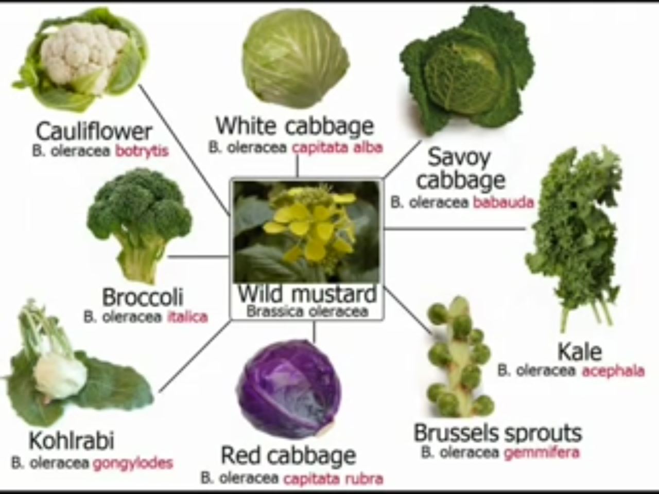Artificial Selection: If you look up the species name of broccoli, cabbage, cauliflower, kale, Brussel sprouts, collard greens, and kohlrabi you will find the same two words: *Brassica oleracea*. Farmers around the world had access to a wild mustard plant, but had a variety of different environmental and nutritional issues to contend with. In order, to get the most out of these plants, farmers selected individuals in the population to breed based on their traits. Some farmers needed variants that could survive in dry soil, while others were in search of variants with a high protein content to feed their starting families. Over time, the selection of these individuals led to entire *Brassica oleracea* populations with the desired trait.

1. What is the force behind evolution in this example?
2. What must be present in the initial population in order for artificial selection to occur?

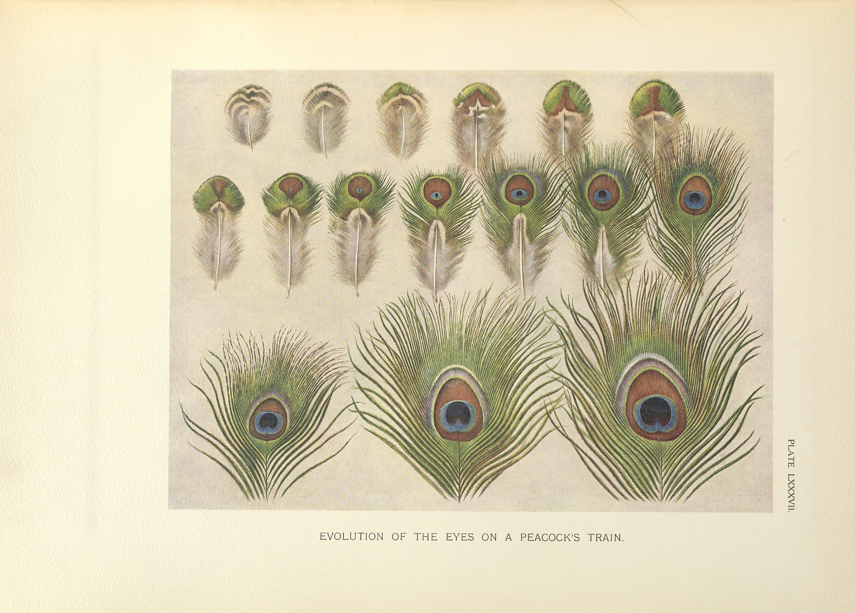Sexual Selection: In peacocks, females select which male they will mate with. The female peacocks are attracted to bright colors, so the males with the brightest colored tail typically get to mate and pass on their genes. Over many generations, the tails of male peacocks have gotten larger and more colorful. The image below shows how the male tail feathers have changed over time.

1. What is the force behind evolution in this example?
2. What must be present in the initial population in order for artificial selection to occur?