Biology Accelerated Name: __________________________________________

Date: ______________

Period: _____

**Biograph Simulation: Gene Regulation and Protein Synthesis**

Every cell in your body has a full set of genes, or “recipes,” to build many different kinds of proteins (including enzymes). Building proteins uses energy and resources. Cells don’t need to build every kind of protein all of the time. To conserve energy and resources, the cell’s genes are normally “turned off.” When environmental conditions change, the genes to build the specific proteins the cell needs to respond to those changes are “turned on.” This process of turning genes on and off is different in prokaryotic and eukaryotic cells. The diagram below shows several differences that exist between prokaryotic and eukaryotic gene regulation.

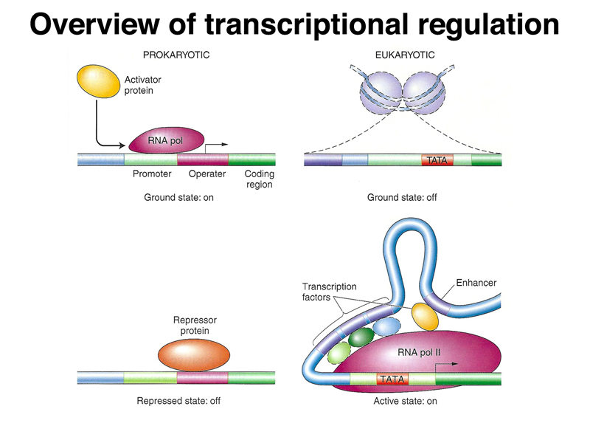

Pre-lab questions: (answer in your lab notebook)

1. How is DNA used by cells?
2. What is the purpose of each gene in a cell?
3. What processes must occur for a gene to be expressed?
4. What two proteins seem to be involved in controlling prokaryotic gene expression?
5. What proteins seem to be involved in controlling eukaryotic gene expression?

In the simulation you view today, you will be observing how bacterial cells control the expression of their lactase gene. The gene and molecules you will be working with in this simulation are pictured below.

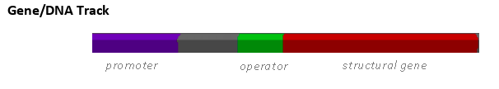

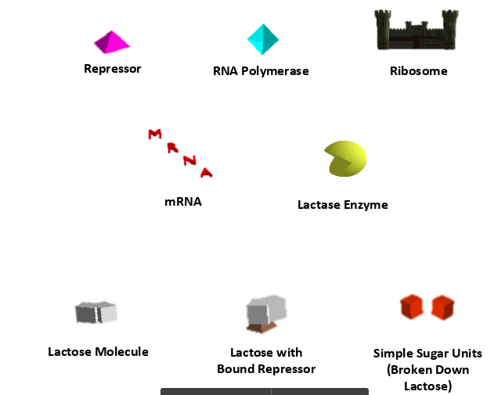

*Procedure Part 1: Genes in their “Turned Off” State*

1. Open the Gene Regulation simulation on our website
2. Click “Run Code” located at the top of your window on the black bar
3. Click on “Setup Gene with Repressor”
4. Click on “Add RNA Polymerase”
5. Click “Run for 40”
6. Observe and record what happens to the RNA polymerase when it makes contact with the promotor region.
7. Observe and record what happens to the RNA polymerase when it reaches the repressor molecule.

*Procedure Part 2: Genes in their “Turned On” State*

1. Click on “Setup Gene without Repressor”
2. Click on “Add RNA polymerase”
3. Observe what is happening and record in your notebook. Be sure to mention the Gene (promotor, operator, and structural gene), RNA polymerase, mRNA, ribosome, and proteins.

Genes must respond to changes in the environment. The gene we are observing in this simulation codes for the enzyme **lactase**. Lactase is an enzyme needed to break lactose (disaccharide) into its monomeric components. The process of breaking down lactose in prokaryotes requires several different enzymes which are all controlled together. A more accurate representation of this **operon** (series of genes controlled by one promotor and operator) is shown below. The three genes involved in lactose breakdown are labeled lacZ, lacY, and lacA.

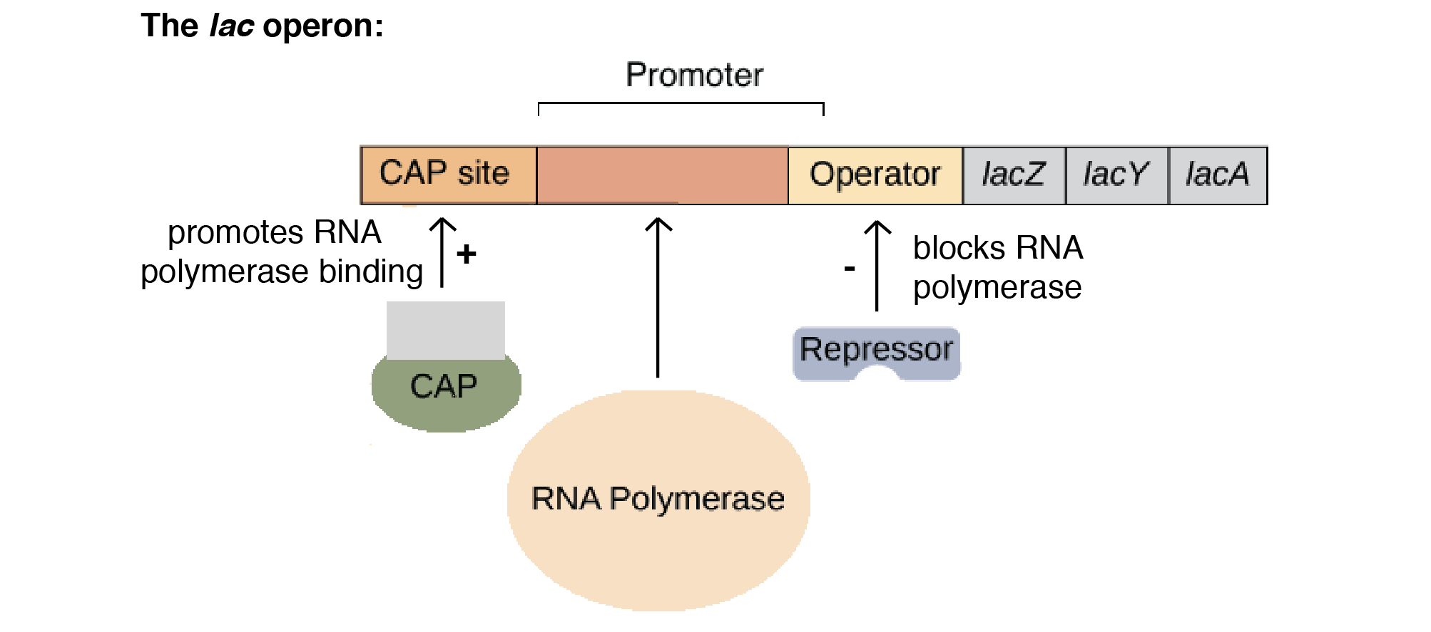

Because this operon is involved in the breakdown of lactose, it is important that it is able to respond to changes in environmental lactose levels.

*Part 3 Procedure: Environmental Influences on Gene Expression*

1. Click on “Setup Gene with Repressor”
2. Click on “Add RNA Polymerase”
3. Click on “Run for 40” and observe what happens
4. Once the simulation has stopped, click on “Add lactose”
5. Click on “Run for 40” and observe
   1. Record what happens to a repressor molecule when the lactose comes close to it.
   2. Record what happens at the operator when the repressor/lactose compound comes close
6. Click on “Setup Gene with Repressor”
7. Click on “Add RNA Polymerase”
8. Click on “Add Lactose”
9. Click on “Run for 200”
   1. Sketch the resulting graph in your notebook and write an appropriate title and annotation

*Analysis Questions: (Answer in your lab notebook)*

1. What are the three general components of an operon?
   1. What bonds to the operator?
   2. What bonds to the promotor?
2. The repressor protein that controls the expression of this operon is coded for by another gene, located elsewhere in the genome. Predict what would happen to gene expression if there was a missense mutation in the gene that codes for the repressor.
   1. How might this change negatively impact the cell?
3. The lac operon is classified as an **inducible operon** meaning it is turned off until it is needed (aka. there is lactose in the environment). Other operons found in prokaryotic organisms are classified as **repressible**. The trp operon is an example of this. Use the image below to explain why the trp operon is classified as repressible.

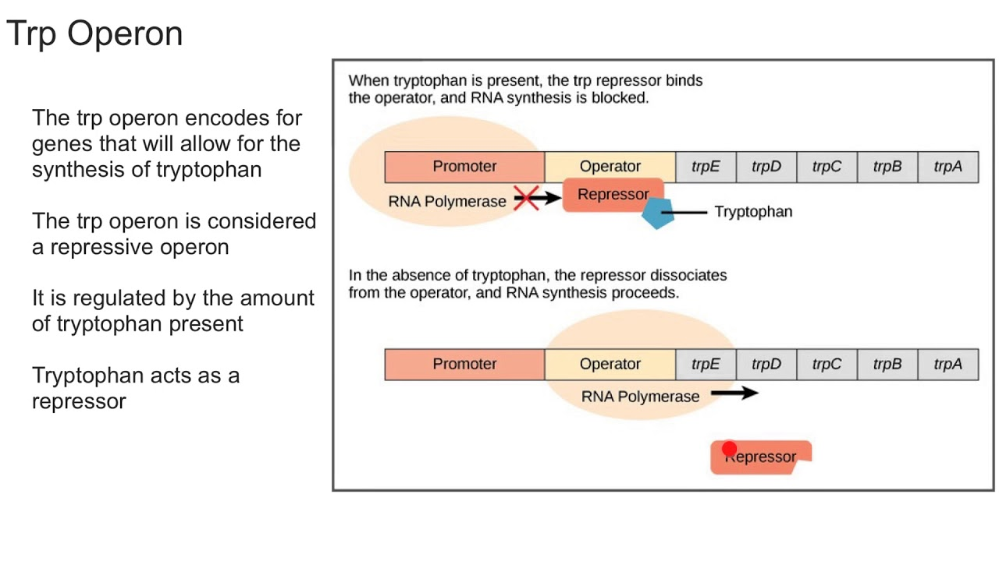

* 1. Think about the proteins that the lac operon codes for. How do these differ from those that are likely coded for by the trp operon?

1. What might be the benefit of organizing genes in operons in prokaryotic cells?
   1. Why might eukaryotic cells not contain operons?
2. The image below shows the many ways in which eukaryotic cells can control gene expression. Fill in the table below the image to summarize how this method would “turn off” and “turn on” gene expression. The first entry is done for you.

|  |  |  |
| --- | --- | --- |
| **Mechanism of Gene Regulation** | **Turns genes “on”** | **Turns genes “off”** |
| **Chromatin Structure** | DNA packs loosely around histones, so enzymes needed for transcription can gain access | DNA packs tightly around histones, so enzymes needed for transcription cannot gain access. |
| **Initiation of transcription** |  |  |
| **RNA splicing** |  |  |
| **Gene Silencing** |  |  |
| **Protein Synthesis** |  |  |
| **Post-translational modification** |  |  |

