**What percentage of a population needs to be vaccinated in order for the population to have herd immunity to a particular disease?**

In this activity we will use a simulation to explore how the percentage of vaccinated people for a particular disease determines if herd immunity occurs.

**Background**Herd immunity, or community immunity, occurs when a sufficient proportion of a population is immune to an infectious disease to make its spread from person to person unlikely. There are two types of active immunity that can occur. Natural immunity occurs when an individual is exposed to an infectious disease, gets the disease, and as a result develops an immune response. Vaccine induced immunity causes the immune system to respond to introduction of a killed or weakened form of the disease causing “bug.” If an immune person is exposed to that “bug” again, their immune system will recognize it and begin producing the antibodies that will kill or neutralize it. Antibodies are disease specific, so you have probably received separate vaccinations for polio, measles and chicken pox, as well as other infectious diseases.

You may be asking “If vaccines are so effective in preventing deadly diseases, then why isn’t everyone vaccinated for these diseases?” The answer to that question is that babies, pregnant women, and those that are receiving chemotherapy or have had an organ transplant can’t be vaccinated. Herd immunity protects those who can’t be vaccinated because the “bug” will not be able to find those individuals.

**The Activity**

Go to <https://www.slnova.org/kroned/projects/697860/> to open the Herd Immunity simulation. When the simulation opens, you will see a picture similar to the one below.

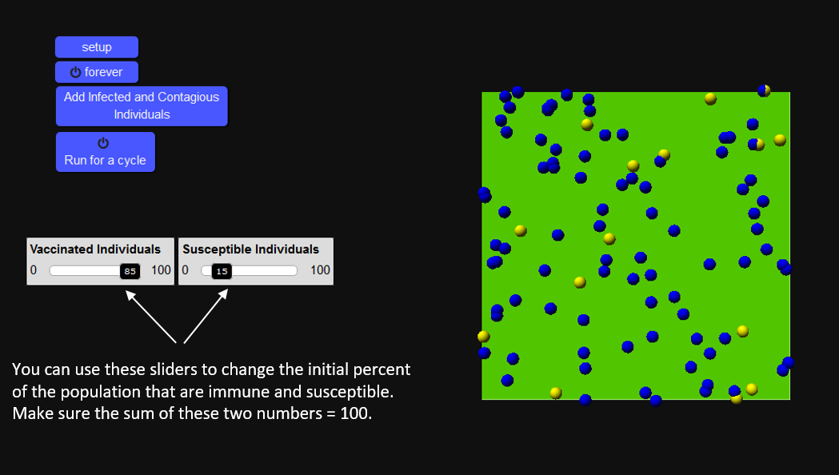

1. Use the sliders to change set the number of vaccinated individuals (blue spheres) to 50 and the number of susceptible individuals (yellow spheres) to 50. Then click the setup button. The particles in the green screen represent that 50% of the population is vaccinated and 50% of the population is susceptible to some disease. Change the sliders to a new percentage.

*What happens to the number of yellow and blue spheres?*

1. Click on the forever button and observe the interaction of the two groups of individuals. After running the program for about ½ a minute click on the run forever button a second time to stop the simulation.

Was there any change in the percentages between the two groups?

*Explain.*

1. Use the sliders to adjust the vaccinated individuals to 10% and the susceptible individuals to 90%. Then click the setup button. Now click on the Add Infected and Contagious Individuals (red spheres) button. After you click on forever observe the interaction between all three groups of individuals.

Describe the interactions between the three groups:

1. *Do any of the yellow spheres turn a different color?*

*Explain any color changes you see.*

*What does this represent about disease transmission?*

1. *Do any of the red spheres change color?*

*Explain the change*

*What does this tell us about immunity?*

1. *Do any of the blue spheres change color?*

*Explain*

1. *When you initially setup the simulation, all of the blue spheres represented those individuals who were vaccinated. As the simulation ran, the number of blue spheres increased. Why did this happen?*
2. Click the forever button to stop the simulation. Use the sliders to change the Vaccinated Individuals to 10% and the Susceptible Individuals to 90%. Then click on the setup button and then the Add Infected and Contagious Individuals. You will now collect data to help you determine how changing the amount of initially vaccinated individuals affects herd immunity. Enter the data into the table below. You will repeat this procedure by changing the ratio of Vaccinated to Susceptible Individuals. Use the headings in the data table as your guide. To run the simulation, this time click on Run for a Cycle. Run for a cycle represents disease progression over a period of time. For each set of data, run the simulation 3 times and record the average number of Infected.

|  |  |  |  |
| --- | --- | --- | --- |
| **Trial** | **Initial # of Vaccinated** | **Initial # of Susceptible** | **Average # of Infected**  **at End of Cycle** |
| 1 | 10 | 90 |  |
| 2 | 25 | 75 |  |
| 3 | 50 | 50 |  |
| 4 | 75 | 25 |  |
| 5 | 90 | 10 |  |

Table 1

1. Let’s now use the community (or herd) of New York City to determine the amount of contagious individuals at the end of the cycle. We’ll make the math easy to determine the number of infected individuals in this community. To determine the number of infected individuals, divide the average number of infected individuals at the end of the cycle to get a percentage and multiply that by the population of NYC (8, 600, 000).

|  |  |  |  |  |
| --- | --- | --- | --- | --- |
| **Trial** | **Initial % Vaccinated** | **Average # of Infected at**  **End of Cycle** (from table 1) | **% Infected** | **# of Individuals in NYC who are Infected** |
| 1 | 10 |  |  |  |
| 2 | 25 |  |  |  |
| 3 | 50 |  |  |  |
| 4 | 75 |  |  |  |
| 5 | 100 |  |  |  |

Table 2

1. The threshold immunity is reached when only a small number, or percentage, of the population is infected and contagious. *Which trial do you believe represents the “threshold” for herd immunity?*

*Explain your reasoning.*

1. *Based on what you learned from this activity, explain how the number of vaccinated individuals affects herd immunity.*