**Vaccines**

**Name: _________________________________**

In a world abounding with unsubstantiated “news” and rumor, it is very important that we learn how to differentiate objective factual data from non-verified, emotionally inflammatory talking points. One way to try to remain objective is to ensure your sources are factual, verified, substantiated, current, and relevant. Another very important way to remain objective is to do your own research on a topic and make up your own mind. Today we will investigate the research and data behind how vaccines are made and data on how they affect the body.

Go to the following website: <https://www.historyofvaccines.org/index.php/content/how-vaccines-work>

**What is the source of this website?**

Follow along through the animations, being sure to carefully read each section. Use the information to complete the activity below.

**Overview:**

1. How do vaccines work? ____________________________________________________________________________________________________________________________________________________________________________________

**Response to Vaccine**

2. How is a vaccine like a pathogen-imposter?_____________________________________________________ ____________________________________________________________________________________________________________________________________________________________________________________

3. What do antigens do?

____________________________________________________________________________________________________________________________________________________________________________________

4. What is the advantage to a vaccine exposing the body to antigens?

____________________________________________________________________________________________________________________________________________________________________________________

**Explain what the following immune cells do during an immune event:**

5. (Dendritic)Antigen presenting cell____________________________________________________________ __________________________________________________________________________________________

6. T Helper Cells____________________________________________________________________________ __________________________________________________________________________________________

7. Plasma B Cells___________________________________________________________________________ __________________________________________________________________________________________

8. Approximately how many different kinds of antibodies are in the human body?________________________ __________________________________________________________________________________________

9. How do antibodies disable antigens? ____________________________________________________________________________________________________________________________________________________________________________________

10. How many types of antigens can a specific antibody attach to?____________________________________

11. What do killer T cells do? ____________________________________________________________________________________________________________________________________________________________________________________

12. What is the purpose of memory cells? ____________________________________________________________________________________________________________________________________________________________________________________

**Response to Pathogen**

13. Do vaccinations prevent a pathogen from entering the body a second time? _________________________

14. What is a secondary response? ____________________________________________________________________________________________________________________________________________________________________________________

15. What do memory T cells do when they encounter a pathogen antigen that they “recognize”? ____________________________________________________________________________________________________________________________________________________________________________________

16. What do memory B cells do when they recognize a pathogen? ____________________________________________________________________________________________________________________________________________________________________________________

17. How does antibody production compare between primary (the first time the pathogen enters your body) and secondary response (the second time the pathogen enters your body)? ____________________________________________________________________________________________________________________________________________________________________________________

18. What are two ways antibodies affect the pathogen? ____________________________________________________________________________________________________________________________________________________________________________________

19. How long do most memory cells remain in the body? ___________________________________________

20. We need to get tetanus, chickenpox/shingles, and other disease vaccine booster shots several times during our lifetime. Explain why this is necessary: ____________________________________________________________________________________________________________________________________________________________________________________

**21. Vaccine Response Activity**

In this module, click on the “vaccine response activity”, and click and drag the cellular structures as you work your way through the simulation. When you are done, insert a screenshot of the activity in the space below. You can get to the screenshot /snipping tool on your Chromebook by following the directions below:

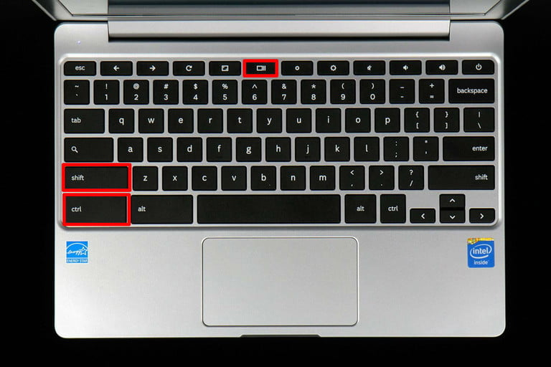

**Step 1: Hold down the Ctrl and Shift keys at once, then press the Switch window button.**

**Step 2: Chrome’s cursor will be temporarily replaced with a crosshair. Click and drag a square across the portion of the screen you want to save, then release the trackpad or mouse button.**

**Step 3: Return to this document and paste the screenshot below.**

**Part 2: Now scroll down to the other animations listed below the animation box, and click on “Herd Immunity”**. Some people can’t get vaccinated for certain diseases — such as babies and younger children (their immune system is not ready yet), people with some serious allergies and those with weakened or failing immune systems (like people who have cancer, HIV/AIDS, type 1 diabetes, age, or other health conditions). But the rest of us can. Read through this section to learn why individual choice can affect a community.

22. What is the principle of herd immunity?

23. What is a herd immunity threshold?

24. What is the most common vaccination rate for most disease herd immunity thresholds?

Now, let’s take a look at how vaccination rates within a population affect disease transmission. Visit this [Vaccination Simulator](https://www.slnova.org/bhemminger/projects/755875/) . In this simulator, you will modify the percent of a population of 100 individuals. You will modify the percentage of vaccinated individuals by moving the scroll bar to the desired spot to change the percentage of vaccination in the community.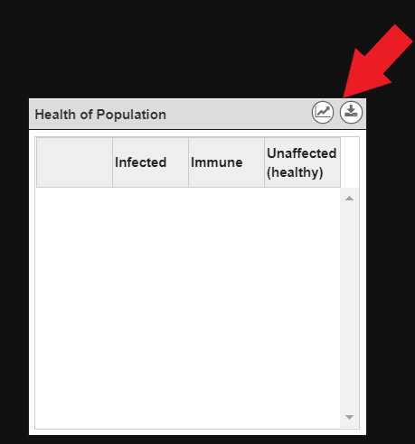

**Note:** *Toggle between the graph and data table view on the simulator to gather your data*

25. Try running the simulation with a low, medium, and high percentage of the population vaccinated. Then, find the lowest percentage needed to reach herd immunity for this disease.

**Trial 1 (low percent vaccination)**

|  |  |  |  |  |  |
| --- | --- | --- | --- | --- | --- |
|  | 0 (start of simulation) | 25 days | 50 days | 75 days | 100 days |
| % vaccinated individuals |  |  |  |  |  |
| % unvaccinated healthy individuals |  |  |  |  |  |
| % sick individuals | 1 |  |  |  |  |

**Trial 2 (medium percent vaccination)**

|  |  |  |  |  |  |
| --- | --- | --- | --- | --- | --- |
|  | 0 (start of simulation) | 25 days | 50 days | 75 days | 100 days |
| % vaccinated individuals |  |  |  |  |  |
| % unvaccinated healthy individuals |  |  |  |  |  |
| % sick individuals | 1 |  |  |  |  |

**Trial 3 (high percent vaccination)**

|  |  |  |  |  |  |
| --- | --- | --- | --- | --- | --- |
|  | 0 (start of simulation) | 25 days | 50 days | 75 days | 100 days |
| % vaccinated individuals |  |  |  |  |  |
| % unvaccinated healthy individuals |  |  |  |  |  |
| % sick individuals | 1 |  |  |  |  |

26. Now, play around with the slider to find the lowest percentage of this population that needed to be vaccinated **in order to reach herd immunity.** Record your data below:

|  |  |  |  |  |  |
| --- | --- | --- | --- | --- | --- |
|  | 0 (start of simulation) | 25 days | 50 days | 75 days | 100 days |
| % vaccinated individuals |  |  |  |  |  |
| % unvaccinated healthy individuals |  |  |  |  |  |
| % sick individuals | 1 |  |  |  |  |

27. Write a CER supporting your reasoning for #26 above.

**Claim:**

**Evidence:**

**Reasoning:**

28. In what way(s) is this simulator useful for understanding herd immunity?

29. No model is perfect. In what way(s) is this simulator not true to life? What factors are not accounted for?

**Part 3: Scroll down and click on the animation “Understanding Risks”**

29. Compare the rates of deaths per 1,000,000 people for cars, poisoning, and the MMR vaccine:

30. List three potential side effects from contracting an influenza B:

31. Explain the findings from rotavirus vaccine trials:

**Part 4: Now, click on “Timeline”** in the upper right menu bar. The click on the green “filter” tab on the right side of the timeline, click “Measles” and the click “filter” again.

Read the information on Measles below the timeline.

32. How contagious is measles for unvaccinated individuals?

33. What are some complications of measles?

34. Before the MMR vaccine, approximately how many people in the USA contracted measles EACH YEAR?

35. After the development of the MMR vaccine, the rate of measles dropped by approximately what percentage?

**Scroll to the year 1998 on the timeline. Click on “MMR Safety Questioned” and read the article.**

36. What did British researcher Andrew Wakefield claim?

37. As a direct result of this claim, what happened to the herd immunity percentages in England over the next decade?

34. What was discovered in 2004?

35. What has happened to Mr. Wakefield, (whose “data” is still considered a source of data by anti-vaccinators today)?

38. What scientifically, objectively obtained data exists to support the claim that vaccines cause autism?

39. What disease was declared eliminated in the USA in 2000?

40. Scroll to 2008. What was this disease status as of 2008? What percent of those affected have not been vaccinated?