Biology Accelerated Name: __________________________________

Date: _____________

Period: ____

**BioGraph: An Introduction to Systems Thinking**

This week, we will begin working on one of the activities for the BioGraph project, which will allow us to use coding and computer science to run a lab simulation.

While each of the activities we will complete for this project will have a different topic in biology, all of them center around the importance of complex systems. **Complex systems** in biology examine how the parts of a system give rise to the collective behaviors of a system, and how the system interacts with its environment. This a relatively new way of thinking in science—rather than addressing concepts as separate islands of topics or discrete units, complex systems focus on making connections to see how elements of the system interact and how patterns emerge over time.

1. Watch along as your teacher plays the video on complex systems. Jot down any important thoughts on complex systems as you watch, focusing on what they are and why they are important to understand. (<https://www.youtube.com/watch?v=g5evD6AQeCQ&feature=youtu.be>)

_________________________________________________________________________________________________________

__________________________________________________________________________________________________________

__________________________________________________________________________________________________________

__________________________________________________________________________________________________________

__________________________________________________________________________________________________________

__________________________________________________________________________________________________________

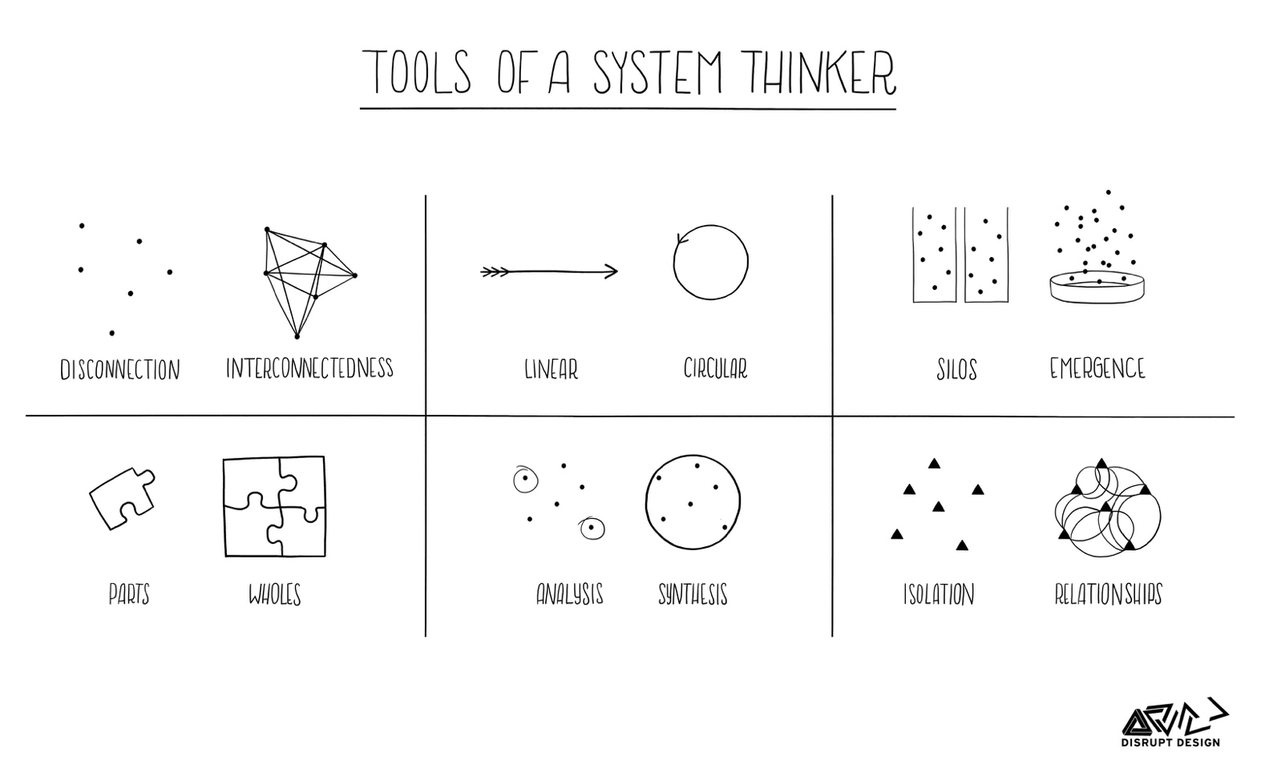__________________________________________________________________________________________________________

Some key characteristics of complex systems are as follows:

* + They are composed of multiple interacting parts (agents) whose interactions give rise to outcomes of the system
  + Agents do not “try to” create outcomes; they emerge as a result of interactions of agents
  + Function of system cannot be predicted by examining its parts
  + System processes are ongoing and dynamic, with no clear beginning or end
  + Complex system is decentralized and self-organizing, meaning there is no single leader who controls the formation, structure, or outcomes of system
  + Small, often random changes at the agent level can lead to large changes at system level

1. Decide if the following are examples of complex systems. Why or why not?
   1. Schools of fish? ________________________________________________________________________________

__________________________________________________________________________________________________

* 1. Beehives? ______________________________________________________________________________________

__________________________________________________________________________________________________

* 1. Symphony orchestra? ________________________________________________________________________

__________________________________________________________________________________________________

* 1. Traffic jams? __________________________________________________________________________________

__________________________________________________________________________________________________

* 1. Super Mario Brothers? _______________________________________________________________________

__________________________________________________________________________________________________

Sometimes, even small choices can have major consequences on a complex system, even unintended ones. Visit the link provided on the “Parable of the Polygons”. (<http://web.mit.edu/djwendel/www/biograph/polygons6-9-18-003/>)

1. Before you “drag and drop” the polygons in the large game board, make a prediction about what this neighborhood will look like after you ensure nobody is unhappy.

__________________________________________________________________________________________________________

__________________________________________________________________________________________________________

__________________________________________________________________________________________________________

1. What are some other examples of complex systems, either from your academic experience, personal life, or in nature?

__________________________________________________________________________________________________________

__________________________________________________________________________________________________________

__________________________________________________________________________________________________________

__________________________________________________________________________________________________________

**Examples of complex systems:**

